<!DOCTYPE html>

<html>

<head>

<meta http-equiv=*"Content-Type"* content=*"text/html; charset=UTF-8"*>

<title>Upload Page</title>

</head>

<body>

<form method=*"POST"* action=*"upload"* enctype=*"multipart/form-data"* >

<table border=“2” align=“center” width=“50%”>

<tr>

<th align=”center” bgcolor=”orange” style=”color:white” colspan=”5”>

<h2>Image Upload Page</h2>

</th>

</tr>

<tr>

<th align=”right”>Select Image:</th>

<td><input type=”file” name=”image”/></td>

</tr>

<tr>

<th align=”right”>Select Name:</th>

<td><input type=”text” name=”name”/></td>

</tr>

<tr>

<td><input type=”Submit” value=”Upload”></td>

<td><input type=”reset” value=”Reset”></td>

</tr>

</form>

</body>

</html>



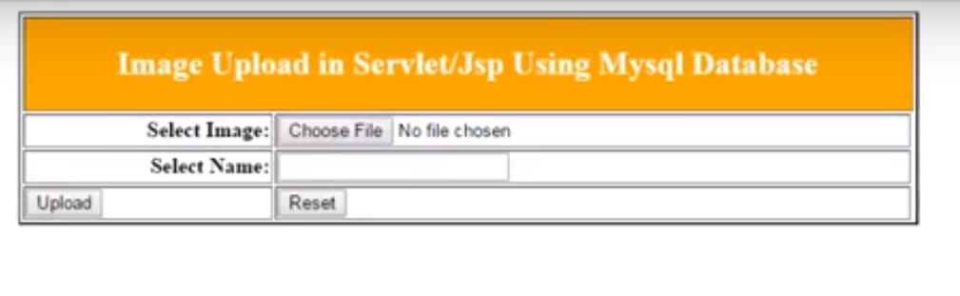



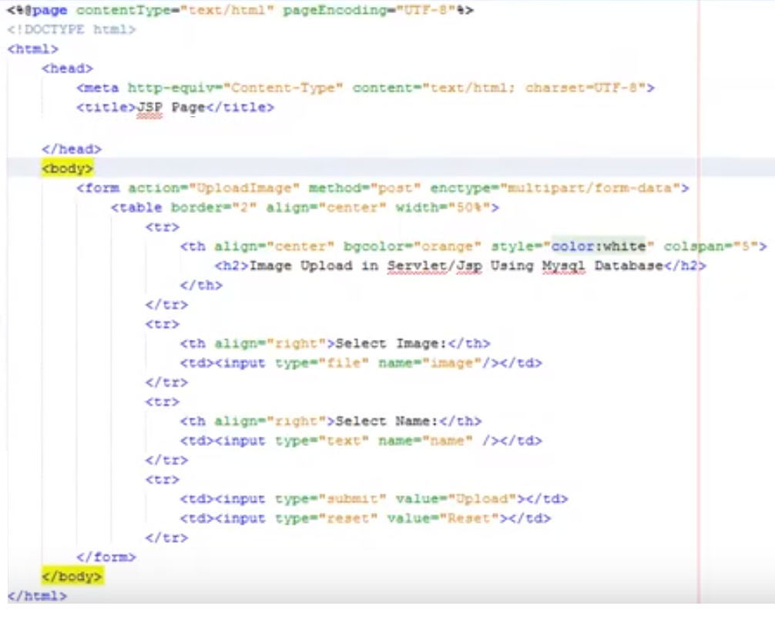

File:

<input type=*"file"* name=*"file"* id=*"file"* /> <br/>

Destination:

<input type=*"text"* value=*"/tmp"* name=*"destination"*/>

</br>

<input type=*"submit"* value=*"Upload"* name=*"upload"* id=*"upload"* />

</form>